Tab 1

EN

Home

Section | Content (directions are written in red for clarification)
Hero Section / Slider | Headline: Expert Veterinary Care, Tailored to Your Pet's Needs  Subheadline: A Pioneering Veterinary Clinic, Providing Exceptional Care Every Step of the Way  Call to Action: Book an Appointment Now (link to contact page / form)
Intro About Elite | Welcome to Elite Vet  Your trusted pet veterinary clinic  We are committed to providing top-quality care for your pets. Our veterinary clinic offers a wide range of services, including routine check-ups, vaccinations, surgeries, & dental care, using the latest technology & under the care & expertise of the best veterinarians in KSA.  Call to Action: Read More…(link to redirect to “About Us” page)
Service Categories | What we offer?  As a leading Riyadh veterinary clinic, we offer a comprehensive range of veterinary services to keep your furry companions happy and healthy.  Read more … (link to services main page)
Why Choose Us | Why choose us?  As a trusted name in the Riyadh veterinary community since 2013, we've helped more than 200,000,000 pets through:  - Personalized Care: Tailored treatment plans for each pet.  - Latest Technology: Cutting-edge equipment for accurate diagnosis.  - Compassionate Staff: A dedicated team that loves animals.  Call to Action: Read More…(link to redirect to “About Us” page)
Our Doctors? | 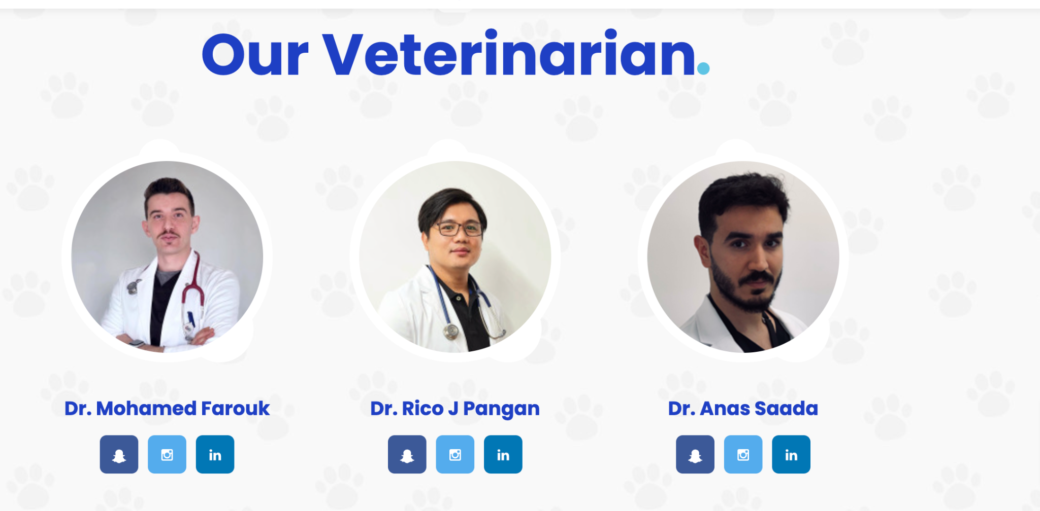  Our Team  Our team of highly skilled veterinarians is committed to providing top-notch care for your furry companions. They're passionate about animal health & dedicated to providing the best possible medical services.  (we can add photos and names of drs or link to the about us page)
Our Partners | Our Partners  Add logos for Vest Van , Elite Falcons
Contact Us |   (standard contact form requirements)
Contact Us | Contact Us  Have a question or concern? Need to schedule an appointment? Contact us today! Our dedicated team is ready to assist you.  Name:  Phone Number:  Email:  Message:  Submit (button)
Footer | logo  +  Elite Veterinary Clinic: Your Trusted Partner in Pet Care.  Discover a new level of veterinary care. From routine check-ups to complex surgeries, our team is dedicated to providing exceptional service & ensuring your pet's well-being.

